**Screenshots for question number 3**

1. Suggestions in the Applicant details:

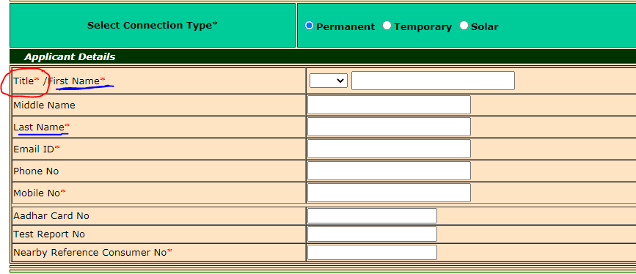

* Title field contains too many options for a user which could be modified as in test case.
* First Name and Last Name are accepting dots as names which is an error.

1. Suggestion for the Billing address:



* The font style of ‘NO’ is not proper and could be modified.

1. Suggestions for the required documents:

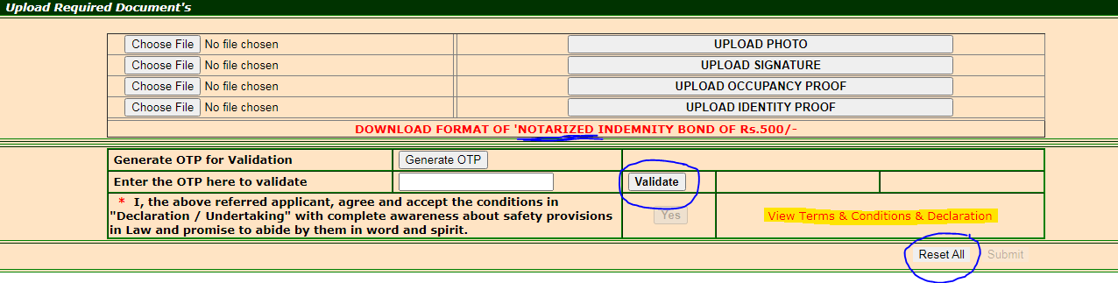

* The validate button is accepting null values and user can click on the button without entering OTP.
* The reset all button when clicked does not reset the uploaded documents of a user.
* The apostrophe before word ‘NOTARIZED’ is not required.

